|  |
| --- |
| **Argentis Consulting** |
| **Apparel & Footwear** |
| UPC Code Setup |



**www.sapapparel.com**

INDEX

1 Setup 3

1.1Create a UPC Block 3

1.2Assign the UPC Block to the company 3

UPC Code Setup

This document explains how to setup the UPC Codes for the SKU’s generated through the Apparel & Footwear Addon.

# Setup

## Create a UPC Block

To create a UPC Block go to: Apparel & Footwear 🡪 Administration 🡪 Inventory 🡪 UPC Block Management 🡪 UPC Block Setup

Type the purchased UPC Code number, choose the EAN Type and finally click on the Add button.

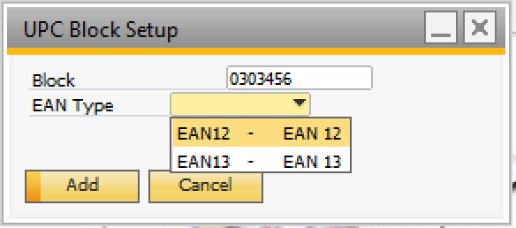

## Assign the UPC Block to the company

To assign the UPC Block to the company go to: Apparel & Footwear 🡪 Administration 🡪 Setup 🡪 General Settings

1. In the Tab Item Master Data, in the input box for the field UPC Fixed Company Digit click on tab and the List of ArgnsUPCBlock window will pop up with all the UPC previously created.
2. Click on the desired UPC Block.
3. Click on the choose button.
4. Back on the Apparel and Footwear Setup window check on the Generate UPC checkbox.
5. Click on the update button.

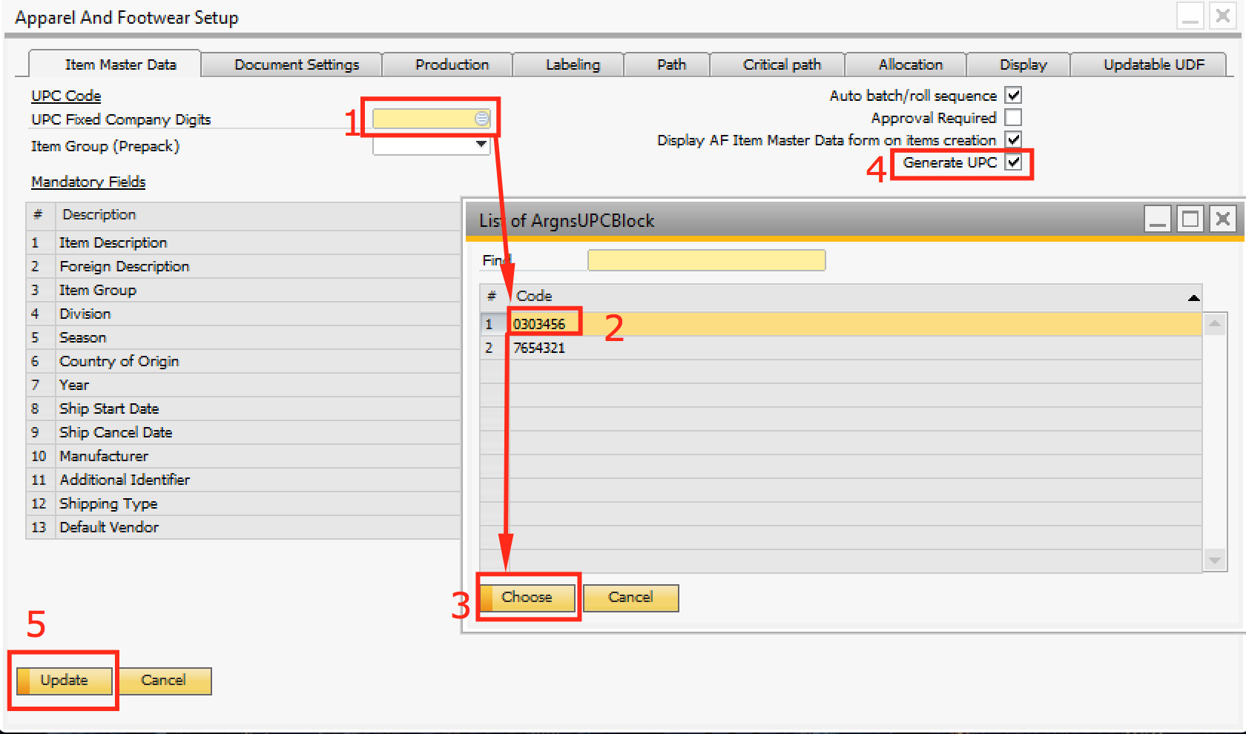



**www.argentisconsulting.com**

**Argentis Consulting** is dedicated to the development, distribution and support of recognized certified solutions for SAP Business One, as an SSP (Software Solution Provider) with a Gold Partner status.

**CONTACT INFORMATION**

|  |  |
| --- | --- |
| **USA**  9744 NW 45th Lane  Doral, FL 33178  info@argentisconsulting.com | **ARGENTINA**  Ávila y Zarate 2048  Cerro de la Rosas, Córdoba,  CP 5009  Córdoba - Argentina  info@argentisconsulting.com |
| **CARIBEAN**  City View Plaza – Suite 301  48 Road 165  Guaynabo, PR. 00968  Puerto Rico  caribe@argentisconsulting.com | **SPAIN**  C/ Juan Bravo N° 3 A 28006  Phone: (+34) 91 123 7263  Madrid - Spain  info@argentisconsulting.com |